|  |  |
| --- | --- |
| **YEAR 8** | **Fossil Fuel Energy** |

|  |  |
| --- | --- |
| **Learning Intentions** | **Success Criteria** |
| Understand fossil fuel energy (a type of chemical energy). | * Identify the Sun as a source of radiant energy * Describe how radiant energy is used in photosynthesis * Describe fuels as a form of stored (chemical) energy * Write a paragraph to describe fossil fuels and explain how they were formed. |

**READ:** *Fossil Fuel Energy*

|  |  |
| --- | --- |
| **Fossil fuels** contain a type of chemical stored energy. Examples of fossil fuels include;   * Coal * Oil * Natural gas   Fossil fuels are formed from the remains of ancient plants and animals. During their lifetime, these ancient plants used solar energy during photosynthesis to build carbohydrates. Animals ate the plants. When the plants and animals died, and if they had been buried deep inside the Earth for millions of years, heat and pressure may have turned their remains into fossil fuels.  In the space draw a flow chart to illustrate this information. |  |

**WATCH:** *Fossil Fuels*

|  |  |
| --- | --- |
| File:Logo of YouTube (2015-2017).svg - Wikipedia | Watch this YouTube video:  <https://www.youtube.com/watch?v=zaXBVYr9Ij0&t=63s> |

**WATCH:** *Why reducing fossil fuel use is important*

|  |  |
| --- | --- |
| File:Logo of YouTube (2015-2017).svg - Wikipedia | Watch this YouTube video:  <https://www.youtube.com/watch?v=oJAbATJCugs&t=2s> |

**ACTIVITY 1:** *Fossil Fuel Energy*

**Activity One: Photosynthesis**

Complete the diagram below by filling in the missing gaps. If you need help use the link provided here: <https://www.britannica.com/science/photosynthesis>

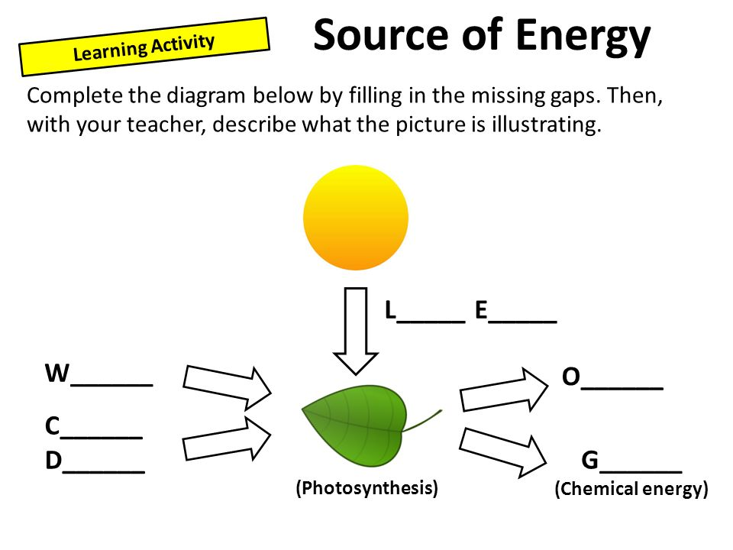

Image: T Dobrich (DOE)

**Activity Two: Fossil Fuel Research**

Use a computer to find the answer to the following questions. Make sure you write answers in words you understand.

**Question 1**

Write a definition for the term fossil fuel.

|  |
| --- |
|  |
|  |
|  |

**Question 2**

List three examples of fossil fuels.

|  |
| --- |
|  |
|  |

**Question 3**

Describe three important uses of fossil fuels in our society.

|  |
| --- |
|  |
|  |
|  |
|  |
|  |
|  |
|  |
|  |

**Question 4**

Describe how living things are formed into fossil fuels.

|  |
| --- |
|  |
|  |
|  |
|  |
|  |
|  |
|  |
|  |

**Question 5**

State one of the main chemical components of fossil fuels. __________________________________________________________________________

**Question 6**

Explain why fossil fuels are not classified as a renewable resource.

|  |
| --- |
|  |
|  |
|  |

**Question 7**

Briefly outline two disadvantages of burning fossil fuels.

|  |
| --- |
|  |
|  |
|  |
|  |

**Question 8**

Burning fossil fuels releases much energy. State where this energy originally comes from.

|  |
| --- |
|  |
|  |

**Question 9**

Name three other energy options that could be used instead of burning fossil fuels.

|  |
| --- |
|  |
|  |
|  |

**Question 10**

Do you think it’s a good idea for countries to try to reduce their use of using fossil fuels? Explain your answer.

|  |
| --- |
|  |
|  |
|  |
|  |
|  |

**END OF WEEK TEST:** *Fossil Fuel Energy*

**Question 1**

Below is an energy flow diagram that illustrates the formation of the fossil fuel, coal which is often used to generate electricity for power. Under each image write the key energy form to complete the energy flow diagram.

|  |  |  |  |  |  |  |
| --- | --- | --- | --- | --- | --- | --- |
| <http://clipart-library.com/free/the-sun-transparent.html> |  | <http://clipart-library.com/clip-art/tree-transparent-clipart-9.htm> |  | <http://clipart-library.com/clip-art/7-79876_coal-car-clipart-wagon-coal-clipart-png.htm> |  | <http://clipart-library.com/clipart/1627463.htm> |
|  |  |  |  |  |  |  |

**Question 2**

Create a list of the advantages and disadvantages of using fossil fuels.

|  |  |
| --- | --- |
| Advantages | Disadvantages |
|  |  |

Rate your understanding of chemical energy:  
 